**GENERIC ELECTIVE – 4**

**(OPEN SOURCE SOFTWARE)**

**Teacher: - Prof. Suparna Bora, Dept. of Computer Science & Engg.**

**ASSIGNMENT – 7.3**

**TOPIC- PYTHON PROGRAMMING**

**Prepared by- Name: - RAJDEEP DAS**

**Roll No. - 202151027**

**Course: - B.Sc. (H) Biotechnology,**

**2nd Semester**

**PROGRAM ON DETERMINING ODD & EVEN NUMBERS**

**Question: - In a list of numbers, verify if the first and the last values are equal and return true/false accordingly. Create new lists during runtime to store odd and even numbers separately from the parent list.**

**Answer:-**

**Input:-**

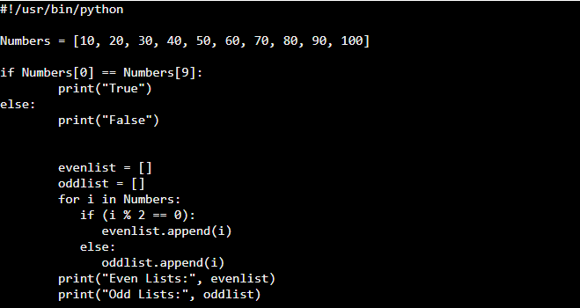

**Output**:-

